Case Study
Profile of M/s DPP Limited
Name of the Enterprise | M/s DPP Limited
Managing Director | TA
Constitution | Private Limited Company
Factory Address | Mahabubnagar
Established | 2013
Line of Activity | Manufacturing of Silica/potash powder from quartz/feldspar mineral stones.
Udyog Aadhar
GST

- Line of activity
Entrepreneur engaged in Manufacturing of Silica/potash powder from quartz/feldspar mineral stones. The final product is used as raw material in ceramic, glass, paint & electrical industries
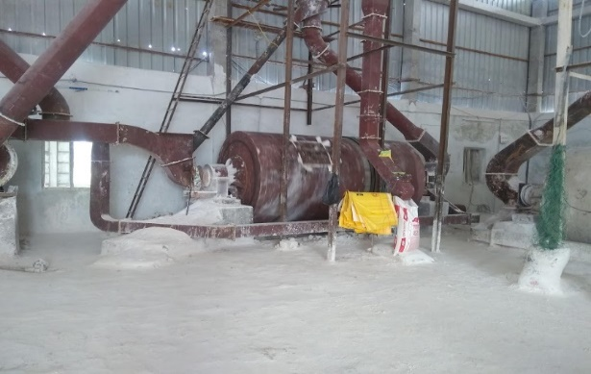
- Managerial Competencies
Mr. TA, Managing Director of the Unit has high involvement in the project as this being his primary source of income. He is first generation entrepreneur with good academic background and he has got knowledge of the Manufacturing activity and run the activity with the help of his skilled staff.

- Machinery/ Manufacturing Process
The firm is engaged in manufacturing mineral powder from quartz/feldspar mineral stones by ball mill technology. The unit has two machines to ground the mineral rocks to final product and one automated carrier belt to dump the final product into containers for transportation. The company purchases input material from M/s. VE (raw material); M/s. RE (packing bags).

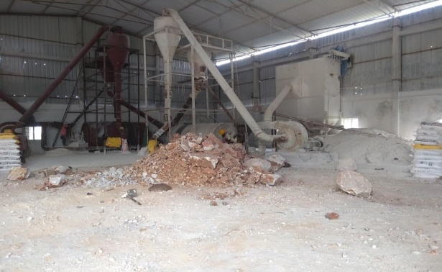

- Marketing
The complete production of the company is supplied to M/s VI, an AA plus Care ratings buyer. The customer has Hyderabad Industries as other backup option.

- TIHCL Intervention
The unit was banking with SFC, Mahbubnagar Branch. The unit was sanctioned Term loan of ₹ 6.20 million by SFC in 2014. There is no formal working capital arrangement. The unit has fallen sick due to high fixed expenses in the initial years of commencement of business.

Client has approached TIHCL for priority release of sanctioned incentives aggregating to ₹ 2.1 million including investment subsidy of ₹1 million to revive the unit.

TIHCL has diagnosed the enterprise and identified following reasons of sickness
- Delay in machinery supply and installation
- The unit at its initial stages couldn’t find appropriate buyer who can pay in 60 days; due to this the receivables were delayed and the payments to the term lender were delayed.
- Natural Calamity damaged factory shed
- The project was not feasible with one machinery as the margins are too low the customer has anticipated this and installed a second machinery with his own funds and made the unit viable after a year of commencement of production
- High cost of borrowed funds and penal interest charged by term lender
As per the TIHCL resolution package, Critical Amount Funding (CAF) loan is required to regularize the account of SFC. SFC Charges 17% interest rate p.a. and provides 2% as interest rebate for prompt and timely payment. SFC levies 2% as penal interest for irregularities in the payment. With TIHCL’s CAF loan this interest burden will be reduced by 2-4%p.a. on term loan of ₹6.2 million. High interest rate is one of the reasons for the stress experienced by the unit.

Key Indicators | Pre-Revival | Post TIHCL Intervention
No of EMIs pending with primary lender | 8 | 0
Capacity Utilization | 75% | 90% (New machinery installed)
Turnover | ₹ 7.0 million | ₹ 11.0 million (Annualised)
Employment | 21 persons | 21 persons

- Labour Status
Gender | Skilled | Unskilled
Men | 04 | 17
Women | 0 | 0
Total | 04 | 17

Livelihood: At 90% of the capacity they have employed 21 workers and their families are dependent on this enterprise which is around 105 individuals including entrepreneurs. The employed workers are sufficient to run at full capacity; the idle time of workers will be reduced.

